

**FASHION SHOP ONLINE**

**Software Design Document**

– Hanoi, May 2021 –

**Table of Contents**

I. Overview 3

1. Code Packages 3

2. Database Schema 3

II. Code Designs 4

1. <Feature/Function Name1> 4

a. Class Diagram 4

b. Class Specifications 4

c. Sequence Diagram(s) 4

d. Database queries 5

2. <Feature/Function Name2> 5

III. Database Tables 5

1. <Table name 1> 5

2. <Table name 2…> 5

# I. Overview

## 1. Code Packages/Namespaces

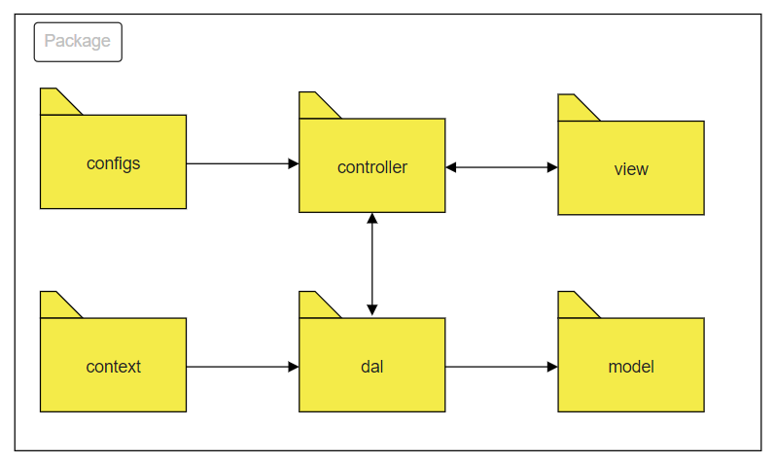

***Package descriptions & package class naming conventions***

| **No** | **Package** | **Description** |
| --- | --- | --- |
| *01* | *controller* | *Acts as a go-between for the service layer and the Front-end, passing on different input requests*  *<Class naming convention>* |
| *02* | *dal* | *This component is used to get data directly FROM the database*  *<Class naming convention>* |
| *03* | *configs* | *This component helps define configuration*  *<Class naming convention>* |
| *04* | *context* | *This component helps connect database*  *<Class naming convention>* |
| *05* | *model* | *This component includes interfaces used to receive data retrieved FROM the database and classes used to receive data*  *<Class naming convention>* |
| *05* | *view* | *This component display front-end*  *<Class naming convention>* |

## 2. Coding Conventions

# II. Code Designs

## 1. Public/Home Page

*[Provide the detailed design for the function <Feature/Function Name1>. It include Class Diagram, Class Specifications, and Sequence Diagram(s)]*

### a. Class Diagram

*[This part presents the class diagram for the relevant feature]*

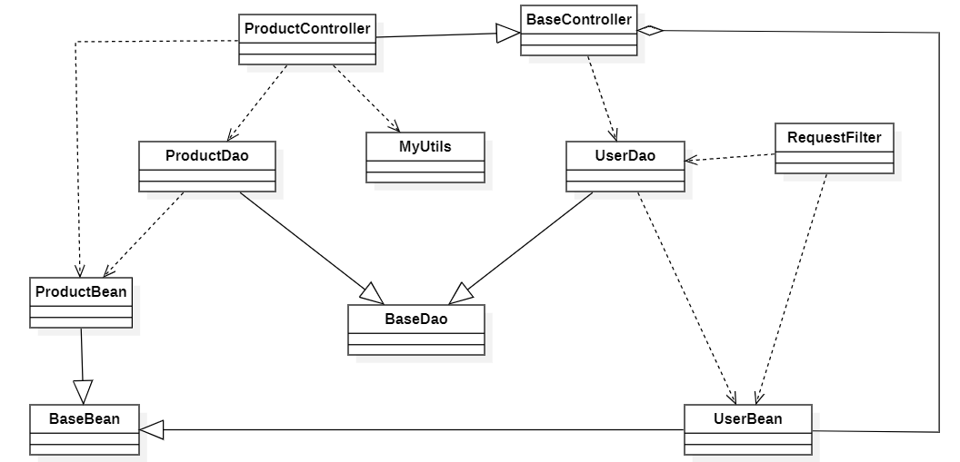

### b. Class Specifications

*[Provide the description for each class and the methods in each class, following the table format as below]*

#### XYZ Class

*[Provide the detailed description for the class methods]*

| **No** | **Method** | **Description** |
| --- | --- | --- |
| *01* | *<method name>* | *<Description of the method, including the inputs, outputs & internal method processing>* |
|  |  |  |

#### ABC Class

***Class Methods***

*[Provide the detailed description for the class methods]*

| **No** | **Method** | **Description** |
| --- | --- | --- |
| *01* | *<method name>* | *<Description of the method, including the inputs, outputs & internal method processing>* |
|  |  |  |

### c. Sequence Diagram(s)

*[Provide the sequence diagram(s) for the feature, see the sample below]*

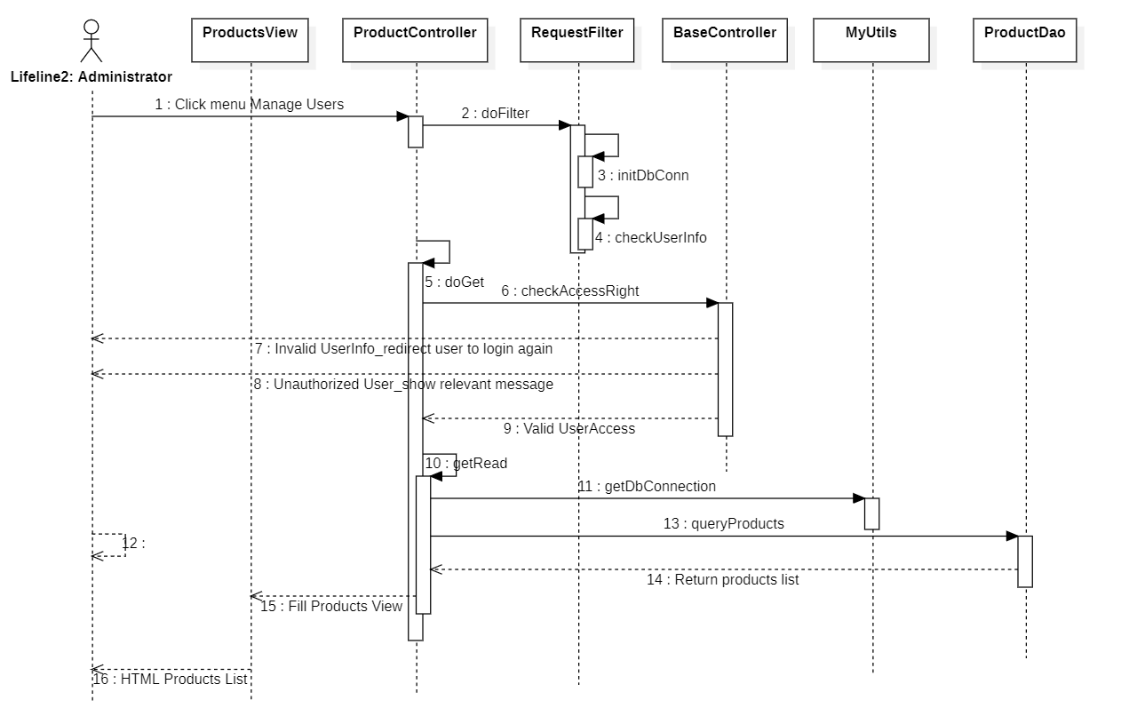

### d. Database queries

*[Provide the detailed SQL (select, insert, update...) which are used in implementing the function/screen]*

## 2. Public/Products List

### a. Class Diagram

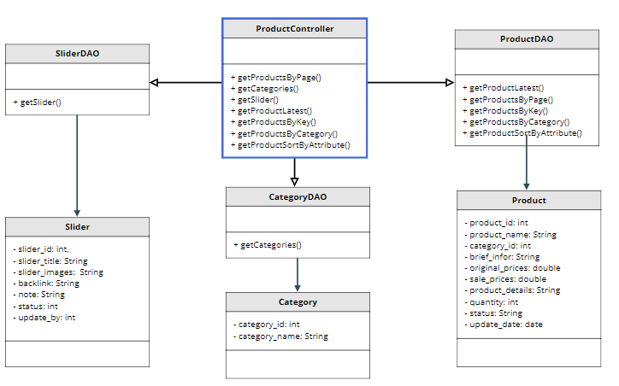

### b. Class Specifications

| **No** | **Method** | **Description** |
| --- | --- | --- |
| *01* | *getProductByPage()* | *Get all products sorted by update date and pagination* |
| *02* | *getCategories()* | *Get all category in database* |
| *03* | *getSlider()* | *Get all slider in database* |
| *04* | *getProductsByKey* | *Get all product in database by keyword entered* |
| *05* | *getProductsByCategory()* | *Get all product in database by selected category* |
| *06* | *getProductSortByAttribute()* | *Get all products sorted by selected method* |
| *07* | *getProductLatest()* | *Get a product latest post* |

### c. Sequence Diagram(s)

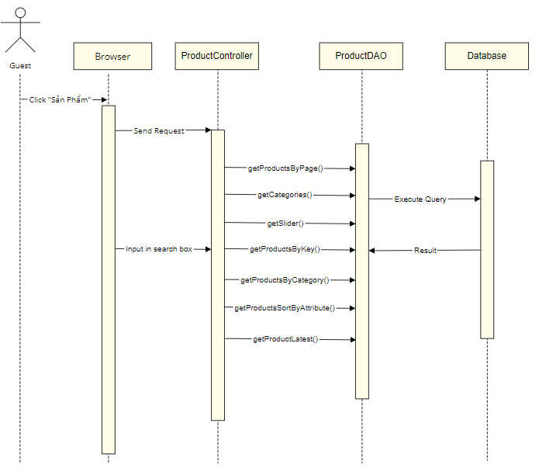

### d. Database queries

* select * from Product order by update offset (?-1)*? rows fetch next ? row only
* Select * from Category
* Select * from Slider
* select * from Product where product_name like ?
* select * from Product where category_id = ?
* select * from Product order by ? ?
* select top 1 * from Product order by update_date desc

## 3. <Common/Reset Password>

### a. Class Diagram

### b. Class Specifications

### c. Sequence Diagram(s)

### d. Database queries

## 4. <Common/Change Password>

### a. Class Diagram

### b. Class Specifications

### c. Sequence Diagram(s)

### d. Database queries

### 

# III. Database Design

## 1. Database Schema

*[Provide the tables relationship like example below – following MySQL database naming convention]*

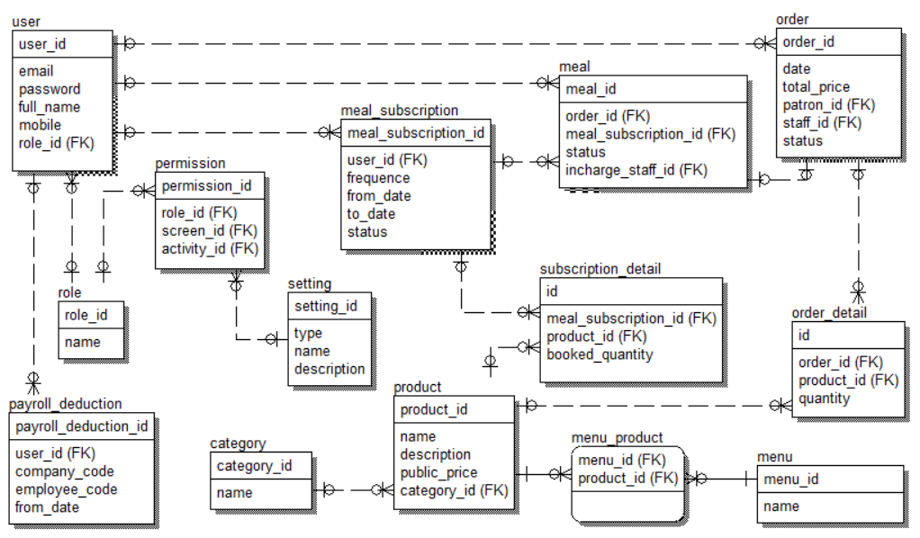

## 2. Table Description

| **No** | **Table** | **Description** |
| --- | --- | --- |
| *01* | *<Table name>* | *<Description of the table>*  *- Primary keys: <<list of primary key fields>>*  *- Foreign keys: <<list of foreign key fields>>* |
| *02* |  |  |